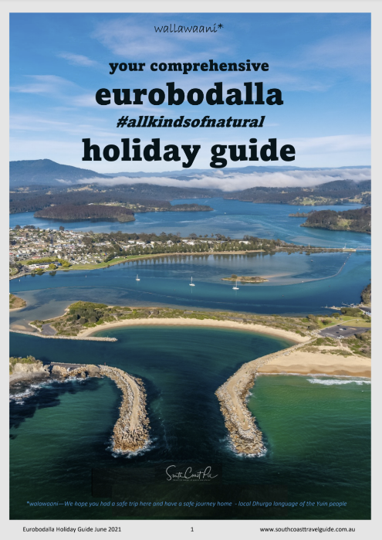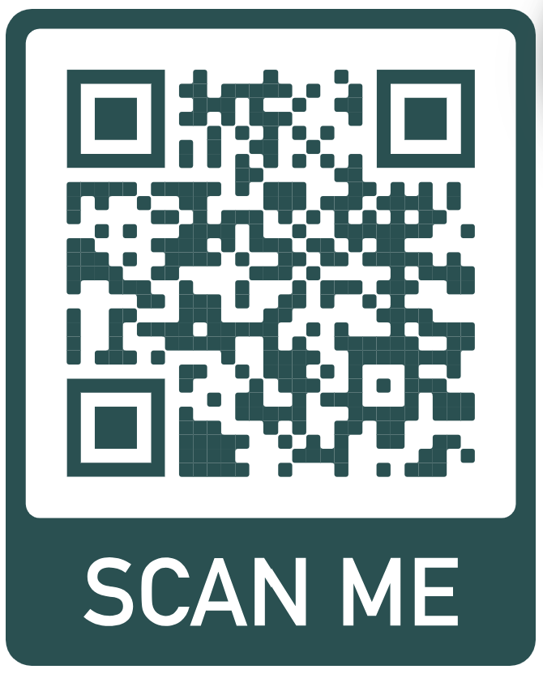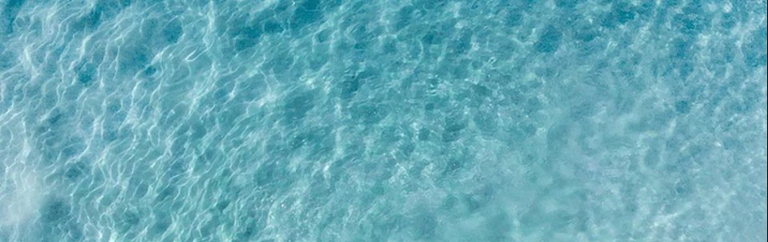

 If you prefer breezing through a publication rather than a website then our 53 page eurobodalla holiday guide will be a great place to start.   
  
**Covering the region from north to south** the guide reveals each town as a separate gem to be visited. There are all the **Must Dos** and **Must Sees** along with the **eurobodalla food guide**  
  
Look for the holiday guide on the website:

Welcome to the South Coast of NSW.   
  
As you can imagine there is much to do and see.   
  
**A good place to start your research** is the *South Coast Travel Guide* website which lists **ALL activities** and **ALL** **the cafes** and restaurants in the Eurobodalla.   
  
The website is easy to navigate, has great **local** info on **beaches**, history, **what to do** and **where to go** to make sure that you don’t miss a thing.   
  
Enjoy.

**www.southcoasttravelguide.com.au**

SOUTH COAST TRAVEL GUIDE

~[Eurobodalla Nature Coast from South Durras to The Tilbas](https://www.southcoasttravelguide.com.au/)~

**Your Comprehensive travel site covering the**

**www.southcoasttravelguide.com.au**